**Example**: <https://2020.igem.org/Team:SDU-Denmark/Team>

**Julie Mallinger**

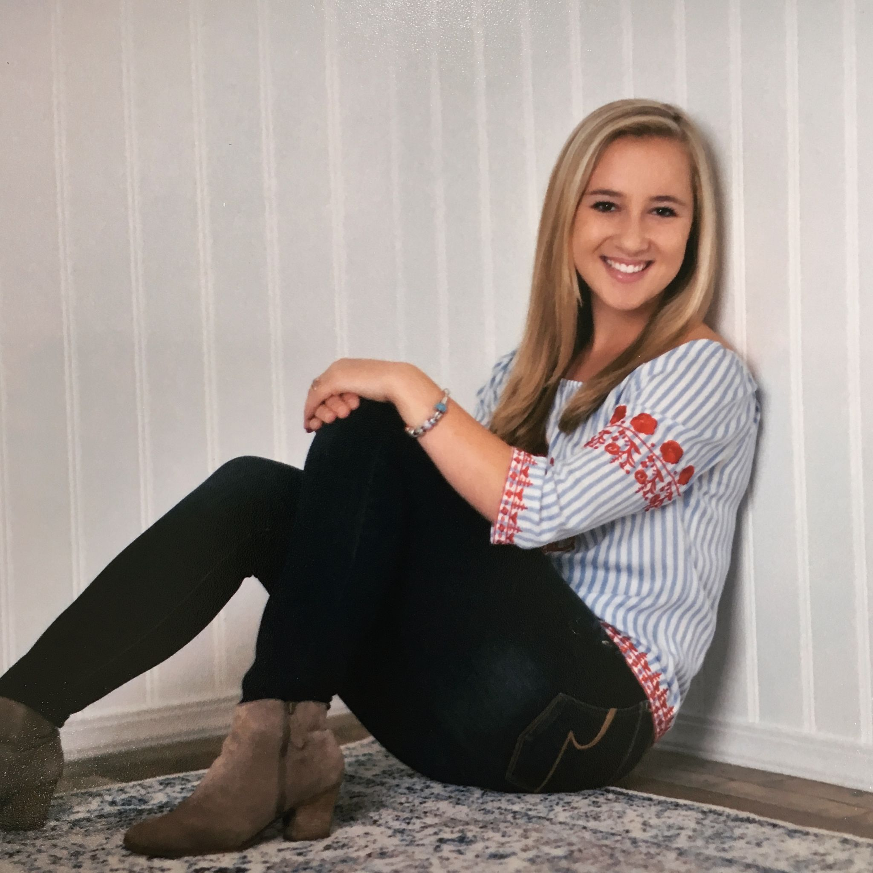

Julie Mallinger is a fourth year biomedical engineering major on the pre-medical track and will be serving as one of the team captains this year. This is her third year on the UF iGEM team and she wanted to continue because she is eager to contribute to the future of synthetic biology. Outside of iGEM, Julie enjoys playing sports, travelling, and spending time with friends. Julie is pursuing a career in medicine to make a positive impact on others.

**David Murcia**

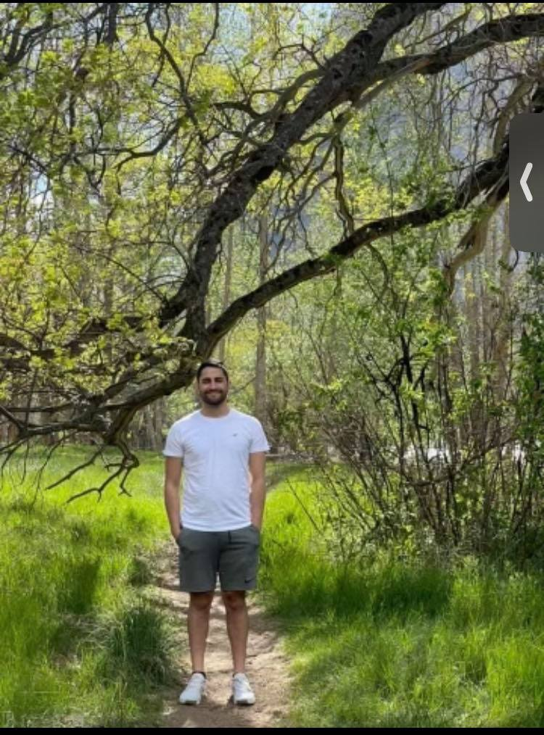

David is a 4th year biology:biotechnology student with a minor in bioinformatics. This is David’s second year on the team and his first serving as one of the Captains. David is a passionate scientist-in-training that is very interested in the interface between computer science and synthetic biology. One day David aspires to become a very skilled genetic engineer, trying to focus on ways that synthetic biology can help alleviate the ever-increasing catastrophe of human-made climate change. In his free time, David likes to spend time with his family, read about genetics, and try to learn how to play the piano.

**Celeste Wilson**

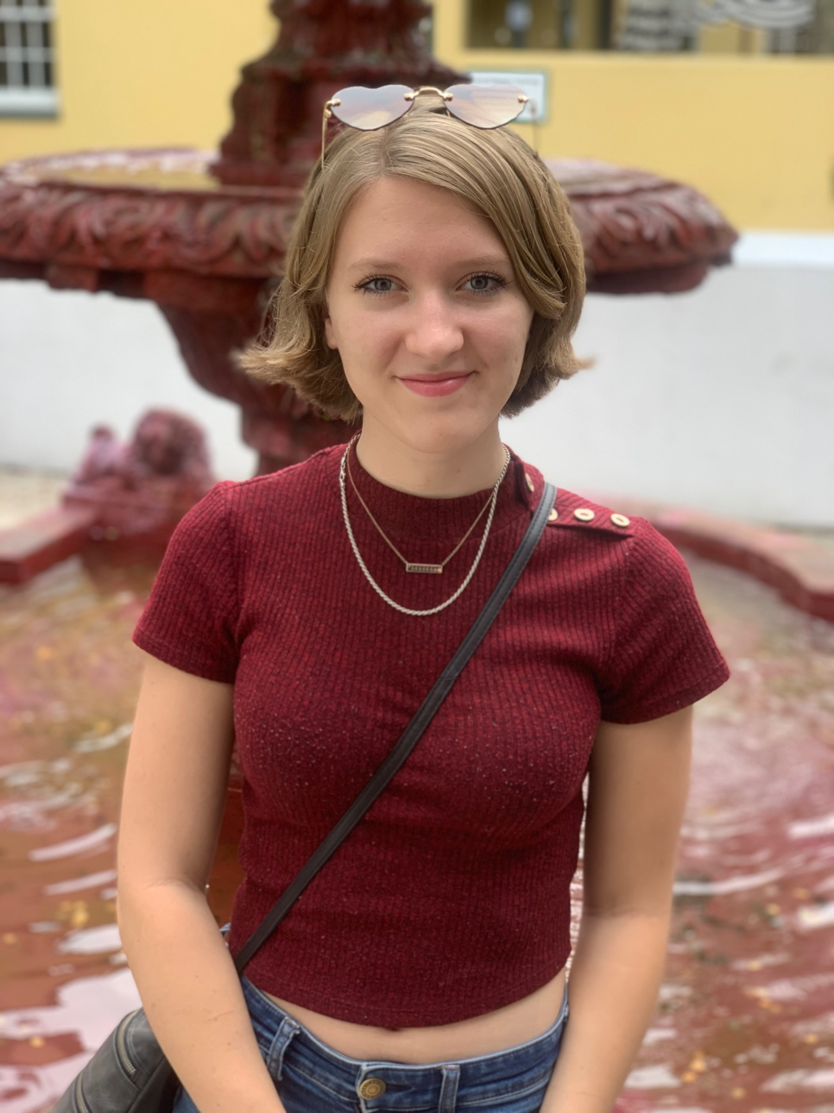

Description:

Celeste Wilson is a fourth year biology major on the pre-med track. This is her second year working with UF iGEM, and she serves as one of the leads of the Human Practices section of the team this year. Passionate about the intersection of synthetic biology and its impact on our community, she will be working with Human Practices to help ensure that this year’s project is accessible and empowering to those it most directly affects. In her spare time, she loves writing poetry and being outdoors. She dreams of publishing her writing and hiking the entire Appalachian trail in her lifetime.

**Jordan Hanson**

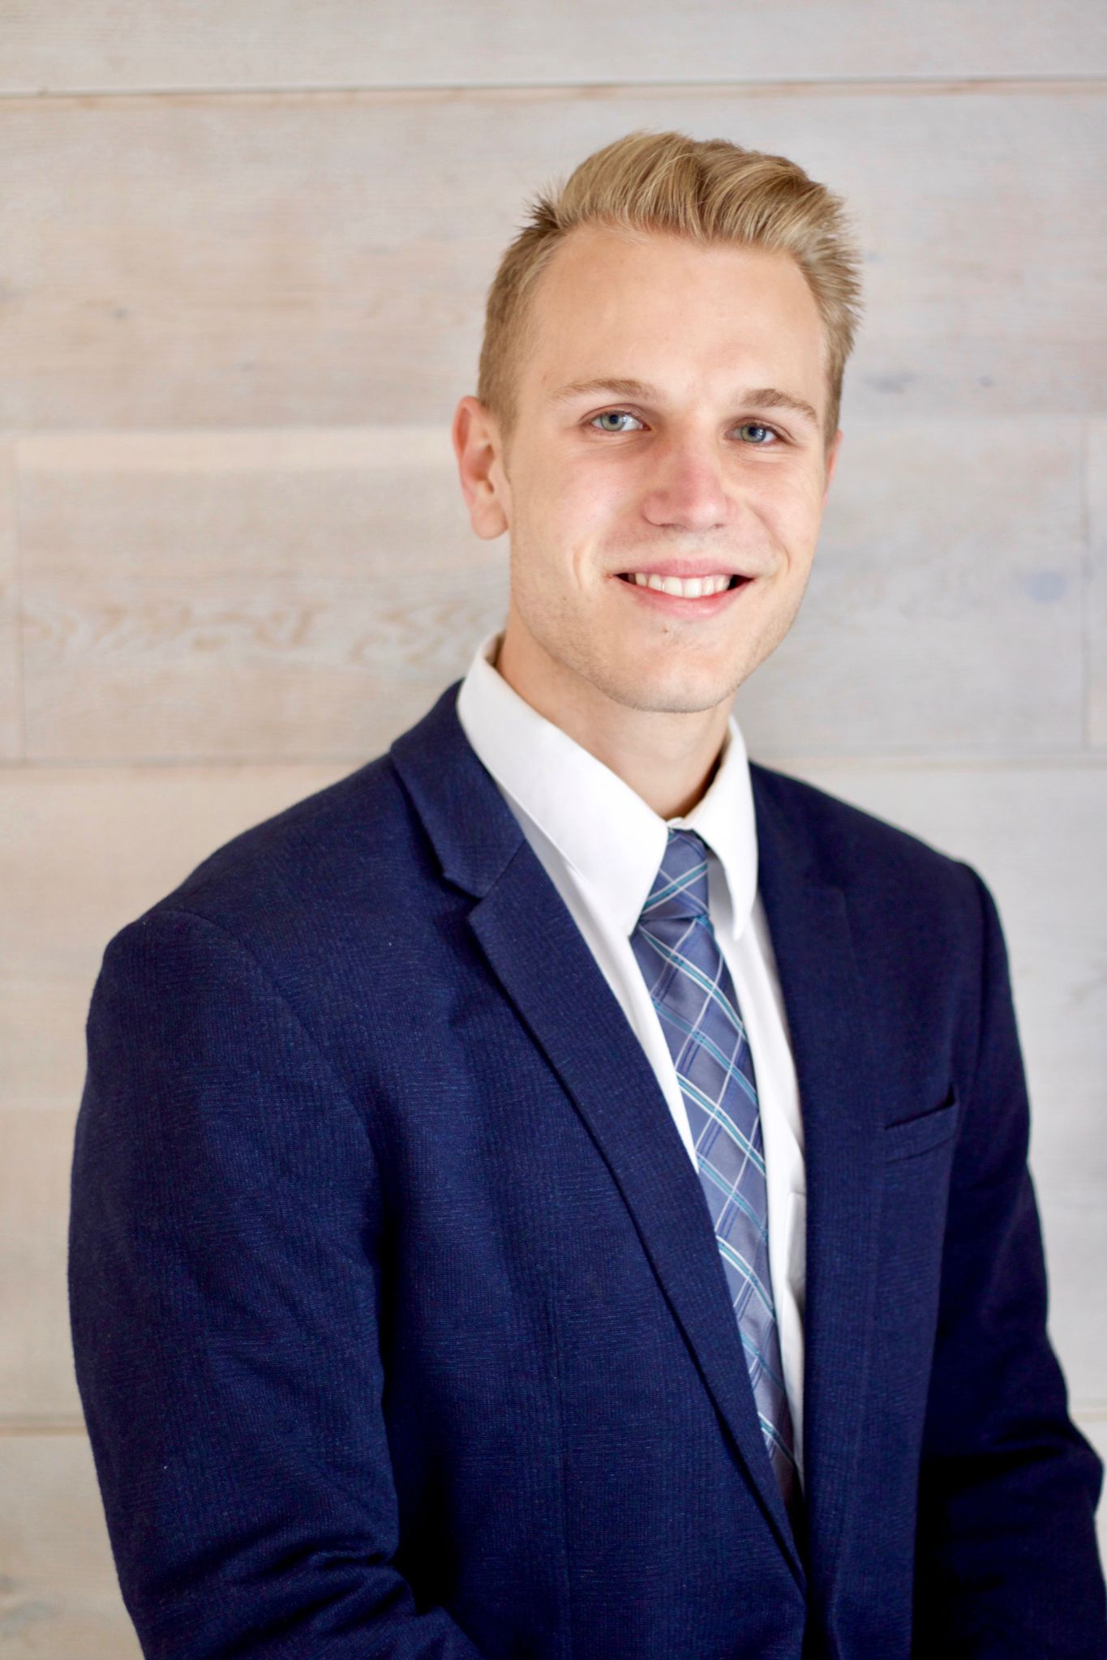

Jordan Matthew Hanson is a third year computer science student. This is his second year as a member of the UF IGEM team and he is eager to design a responsive and engaging website for the team. His hobbies include fitness, hanging out with friends, and the beach. His favorite beverage is almond milk and his favorite show is Impractical Jokers. Jordan Matthew is pursuing a career in software to create software solutions that save time, connect people of different backgrounds, and solve problems that negatively impact society.

**Ryanne Thelwell**

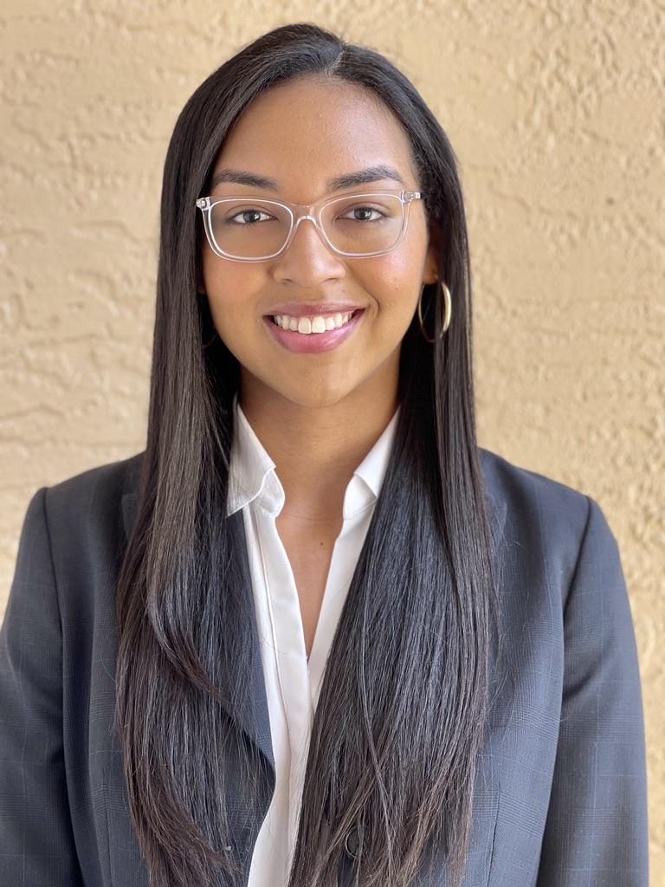

Ryanne Thelwell is a third year microbiology and cell sciences major and Japanese language and pathology dual minor on the pre-medical track. This is her second year as a member of the UF iGEM team and is serving as one of the leads for the Human Practices division. Outside of school, she enjoys trying out new baking recipes and gardening. Ryanne is pursuing a career in the medical field to combat health disparities and improve health resource accessibility.

**Sarah Bahsoun**

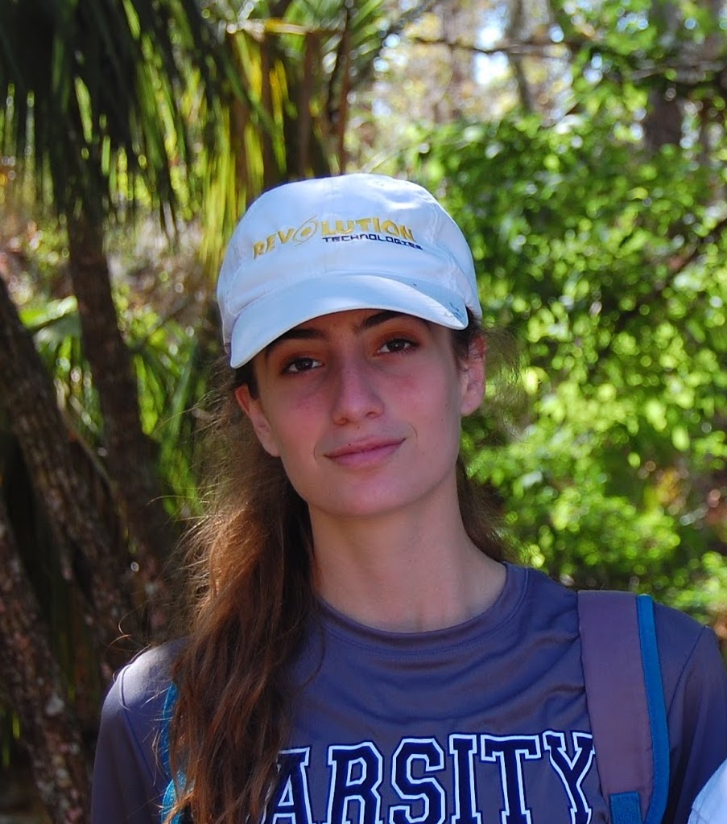

Member Spotlight:

Sarah Bahsoun is a second year microbiology and cell sciences major on the pre-medical track. This is her first year as a member of the UF iGEM team and she is working on the Human Practices section of the team. While having little background in synthetic biology, Sarah is excited both to learn and share that knowledge with others in the community through her role on the Human Practices team. Outside of iGEM, Sarah is involved in Parkinson’s disease research at the McKnight Brain Institute.

**Nick Blumenthal**

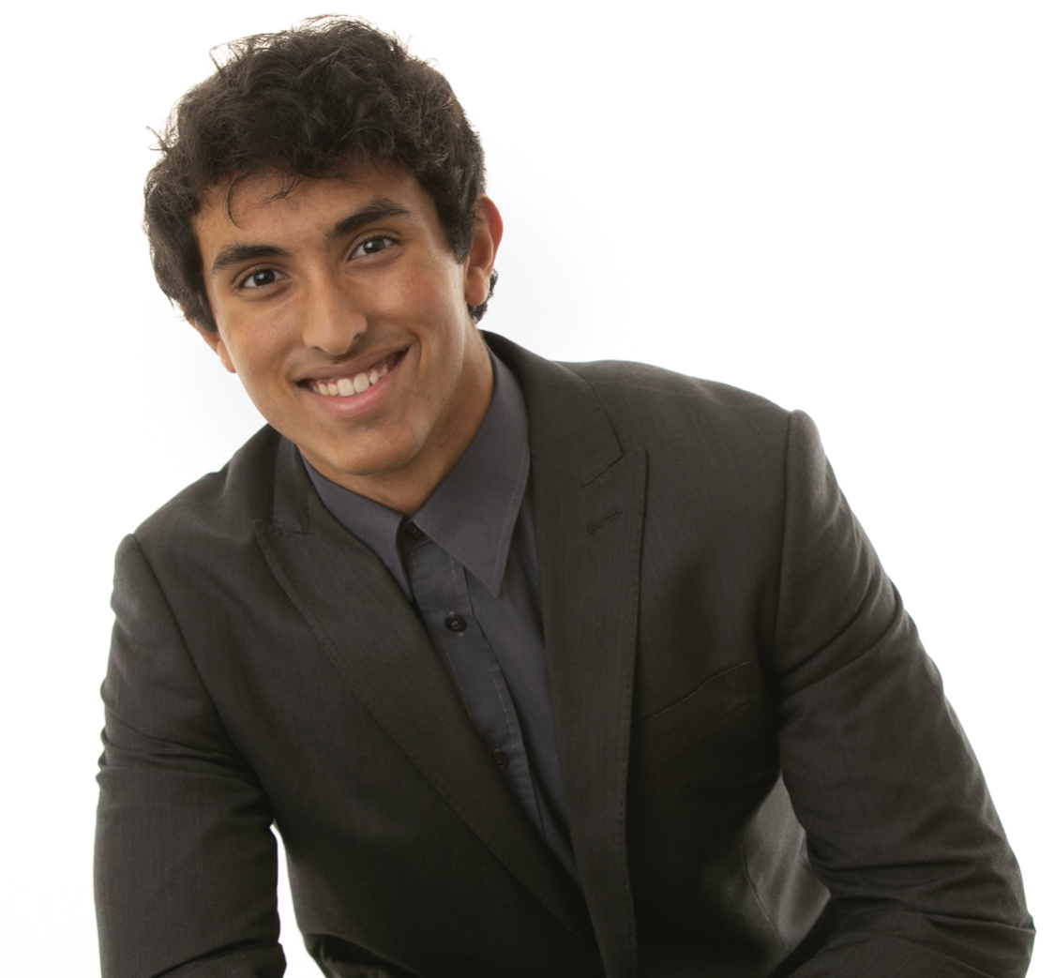

Nick Blumenthal is a first year applied physiology and kinesiology major on the pre-medical track. This is his first year as a member of the UF iGEM team, and he is excited to learn and in the lab. Helping come up with the project is only half the work, but he is just as excited for development and implementation as well. Aside from iGEM, Nick enjoys helping advance his sport of calisthenics and whipping up new dishes in the kitchen. Moreover, he is also involved in regenerative medicine research at the Cancer & Genetics Institute.

**Lejla Ramić**

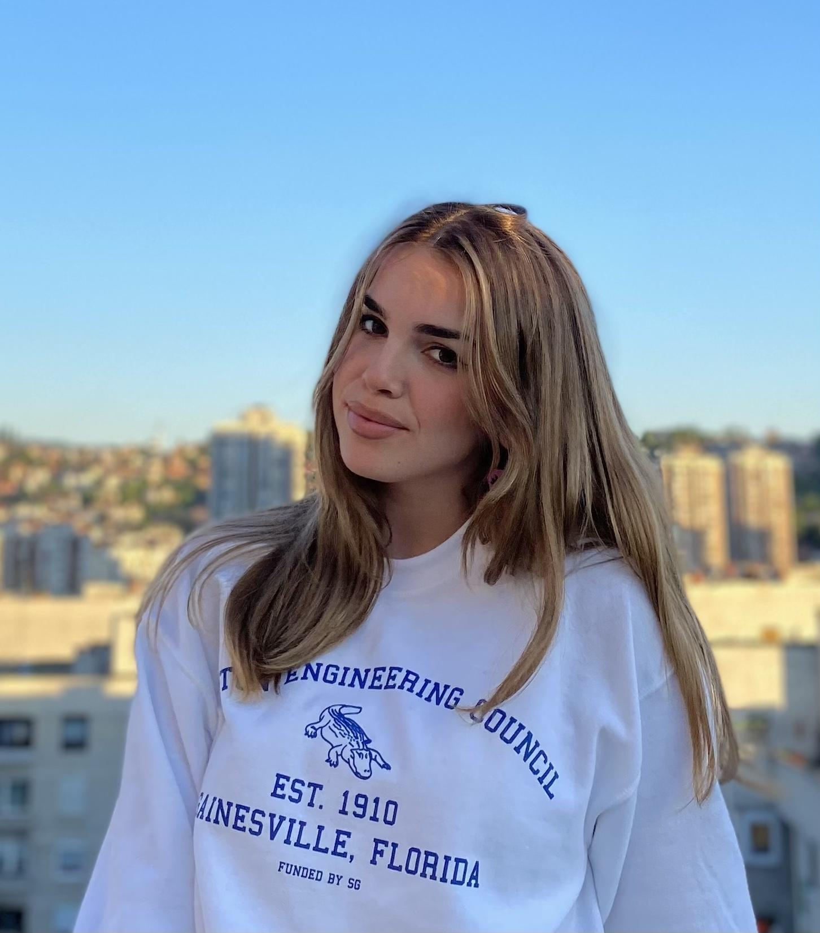

Lejla Ramić, now senior at the University of Florida in the Biological Engineering program, specializes in the field of Biosystems with specific interest in Genetic Engineering and Biotechnology. In the UFlorida iGEM team, Lejla is a part of the dry lab team, where they operate in Python, executing mathematical formulations and analysis of the UFlorida project. In her free time, Lejla enjoys playing the piano. She plans to remain in the biotech field and will continue to make a positive impact within the field.

**Alessio Barca**

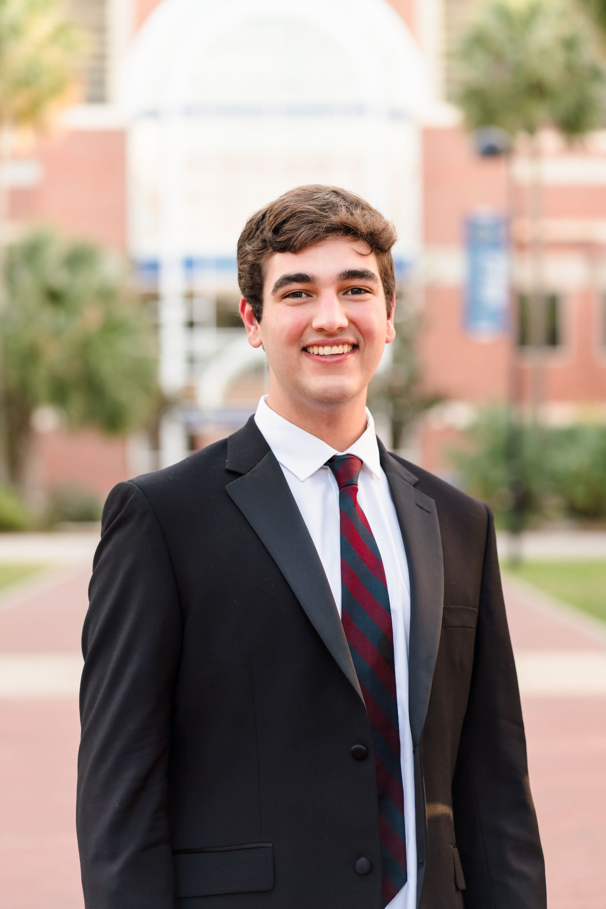

Alessio is a 3rd year biochemistry major on a pre-medical track. As a first time member of the iGEM Human Practices team, he will be collaborating with the rest of the team to evaluate our project’s ethics, facilitate outreach with the Gainesville community, and create connections with other iGEM teams. Alessio is passionate about chemistry, anatomy, and health disparities throughout the globe. In his spare time, Alessio finds much enjoyment in cooking, weight lifting, and going on nature trails.

**Vedic Sharma**

Vedic is a 2nd year engineering major, and this is his first year on the team. He is part of the dry lab team, and works to develop python solutions to model the project. Aside from IGEM, Vedic is also involved in brain-imaging research at the McKnight Brain Institute and genetics research at the McIntyre Lab. Vedic is interested in the pre-med track, and hopes to become a physician in the future. In his spare time, Vedic enjoys studying history, playing chess, and reading.

**Abby Hirshberg**

Abby Hirshberg is a fourth year biomedical engineering student with a Spanish minor. This is Abby’s first year as a part of UF iGEM and will be serving as one of the members of the wet lab team; she is looking forward to spending time in the lab to execute the project and learn more about synthetic biology. Following graduation, Abby hopes to pursue a master’s in Genetic Counseling to use her passion for the study of genetics to help those around her achieve their personal familial and health-related goals. Outside of iGEM, Abby enjoys spending time with her friends, traveling, and trying new foods.

